**Q1 For different category of acquirers, what is the average number of months since the inception of the acquired company after which they are acquired**

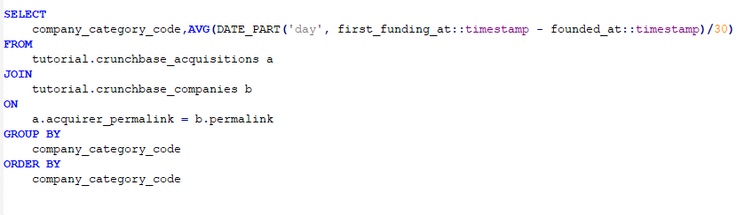

**Q2 Is there any trend for quarters when more companies are acquired**

**Q3 For each company_category_code identify the average raised_amount_usd per quarter**

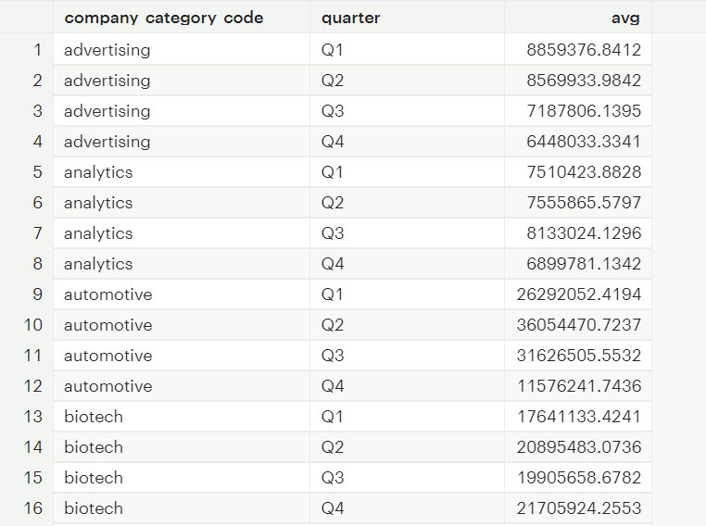

**Q4 Which investor (company ) is more likely to invest in USA based companies?**

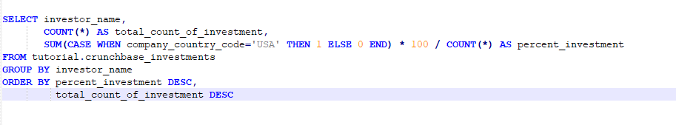

**Q5 For different type of funding rounds, what is the average raised amount per quarter**

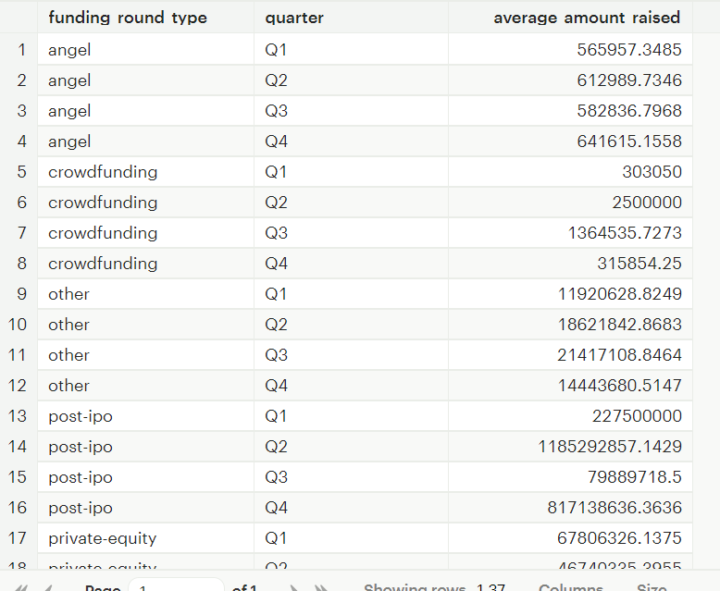

**Q6 Identify companies that received an investment from Japan following an investment from Great Britain where investor is finance category company**

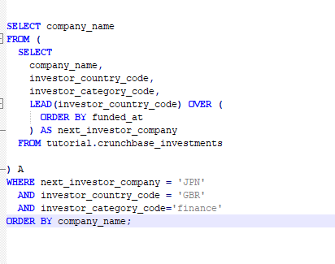

**Q7 Out of all 'operating' status companies, which category of companies have the highest average funding_total_usd?**

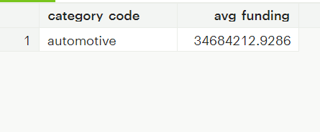

**Q8 For each category, what percent of companies received funding within 3 years of their founding?**

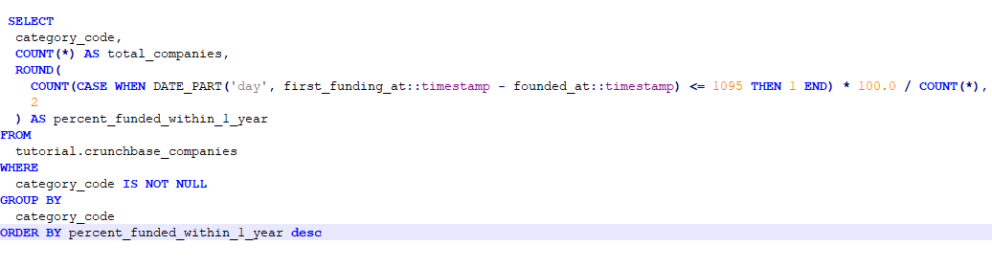

**Q9 Clean the 'last_funding_at' column (convert it to time stamp) and get the time difference with the current time.**

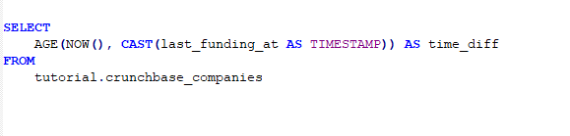

Q10 . Average Funding based on Countries

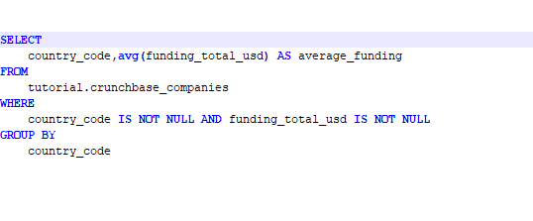

**Q1 For different category of acquirers, what is the average number of months since the inception of the acquired company after which they are acquired**

SELECT company_category_code,AVG((DATE_PART('year',CAST(acquired_at AS DATE)) - DATE_PART('year', CAST(founded_at AS DATE))) * 12 +

(DATE_PART('month',CAST(acquired_at AS DATE)) - DATE_PART('month', CAST(founded_at AS DATE))))

FROM tutorial.crunchbase_acquisitions

JOIN tutorial.crunchbase_companies

ON tutorial.crunchbase_acquisitions.acquirer_permalink = tutorial.crunchbase_companies.permalink

GROUP BY company_category_code

SELECT

company_category_code,AVG(DATE_PART('day', first_funding_at::timestamp - founded_at::timestamp)/30)

FROM

tutorial.crunchbase_acquisitions a

JOIN

tutorial.crunchbase_companies b

ON

a.acquirer_permalink = b.permalink

GROUP BY

company_category_code

ORDER BY

company_category_code

**Q2 Is there any trend for quarters when more companies are acquired**

SELECT

acquired_quarter, COUNT(*) AS count

FROM

tutorial.crunchbase_acquisitions

GROUP BY

acquired_quarter ;

**Q3 For each company_category_code identify the average raised_amount_usd per quarter**

SELECT company_category_code, RIGHT(funded_quarter, 2) AS quarter,AVG(raised_amount_usd)

FROM tutorial.crunchbase_investments

GROUP BY company_category_code,quarter;

**Q4 Which investor (company ) is more likely to invest in USA based companies?**

SELECT investor_name,COUNT(*) as total_count_of_investment,

COUNT( CASE WHEN company_country_code='USA' THEN 1 ELSE NULL

END)*100 / COUNT(*) AS percent_investment

FROM tutorial.crunchbase_investments

GROUP BY investor_name

ORDER BY percent_investment DESC ,total_count_of_investment DESC

**Q5 For different type of funding rounds, what is the average raised amount per quarter**

SELECT funding_round_type, RIGHT(funded_quarter, 2) AS quarter, AVG(raised_amount_usd) AS Average_Amount_Raised

FROM tutorial.crunchbase_investments

GROUP BY funding_round_type,quarter;

**Q6 Identify companies that received an investment from Japan following an investment from Great Britain where investor is finance category company**

SELECT company_name

FROM (

SELECT

company_name,

investor_country_code,

investor_category_code,

LEAD(investor_country_code) OVER (

ORDER BY funded_at

) AS next_investor_company

FROM tutorial.crunchbase_investments

WHERE investor_category_code = 'finance'

) A

WHERE next_investor_company = 'JPN'

AND investor_country_code = 'GBR'

ORDER BY company_name;

**Q7 Out of all 'operating' status companies, which category of companies have the highest average funding_total_usd?**

SELECT category_code,AVG(funding_total_usd) AS avg_funding

FROM tutorial.crunchbase_companies

WHERE status='operating'

GROUP BY category_code

ORDER BY avg_funding DESC

LIMIT 1

**Q8 For each category, what percent of companies received funding within 3 years of their founding?**

SELECT

category_code,

COUNT(*) AS total_companies,

ROUND(

COUNT(CASE WHEN DATE_PART('day', first_funding_at::timestamp - founded_at::timestamp) <= 1095 THEN 1 END) * 100.0 / COUNT(*),

2

) AS percent_funded_within_1_year

FROM

tutorial.crunchbase_companies

WHERE

category_code IS NOT NULL

GROUP BY

category_code

ORDER BY percent_funded_within_1_year desc

**Q9 Clean the 'last_funding_at' column (convert it to time stamp) and get the time difference with the current time.**

SELECT

AGE(NOW(), CAST(last_funding_at AS TIMESTAMP)) AS time_diff

FROM

tutorial.crunchbase_companies